**SOFTWARE REQUIREMENT SPECIFICATION**

_____________________________________________

**ROOM BOOKING AND RENTAL**

Version: **1.0**

**Prepared by Group 06:**

20521486 Dang Ba Kien

20521719 Tran Linh Nhi

# **Document Change Record Sheet**

***\* A – Add, U – Update, D – Delete***

|  |  |  |  |  |  |
| --- | --- | --- | --- | --- | --- |
| **Date** | **Contents are changed** | **Reason** | **Action** | **Short description** | **Version** |
| 20/3/2022 |  |  | A | Document for the first version | 1.0 |

**Table of Contents**

**Document Change Record Sheet** 2

**1.** **Introduction** 5

1.1. Purpose 5

1.2. Scope 5

1.3. Definitions, Acronyms and Abbreviations 5

1.4. Document Overview 6

1.5. Document Conventions 6

1.6. Intended Audience 6

1.7. Reference 7

**2.** **Overall Description** 8

2.1. User Requirements 8

2.2. System Requirements 8

2.3. Development Environment 8

**3.** **Functional Requirements** 9

3.1. Use Case Diagram 9

3.2. Use Case DiagramList of Actors 9

3.3. List of Use Cases 10

3.4. Use Case Specification 12

3.4.1. Login 12

3.5. Database Design 21

3.6. ERD 22

3.7. Activity Diagram 23

3.7.1. Information change diagram operation 23

3.7.2. Information change chart 24

3.7.3. Diagram of changing password 25

3.8. Class Diagram 26

3.9. Sequence Diagram 27

**4.** **Non-Functional Requirements** 27

4.1. Usability 27

4.2. Reliability 27

4.3. Ability to support 27

4.4. Supportability 28

4.5. Design Contraints 28

4.6. Reusability 28

**5.** **Functional requirements** 29

**6.** **Interface** 31

**7.** **Appendixes** 48

7.1. Glossary 48

7.2. Messages 48

7.3. Issues List 49

# **Introduction**

## Purpose

Today, the application of information technology and computerization is considered as one of the decisive factors in the activities of governments, organizations, as well as companies; it plays a very important role, can make strong breakthroughs.

The construction of management software to serve the unique needs of organizations, companies and even individuals, today, is not strange.

The operation of a large-scale travel company will be enhanced and expanded if a good management software is built. Starting with this idea, along with the suggestions of Mr. Le Thanh Trong, we have implemented the project "ROOM BOOKING AND RENTAL" as shown below..

## Scope

This document describes the requirements of the above-mentioned system. It is meant to be used by the developers and will be the basis for validating the final delivered system. Any changes made to the requirements in the future will be made with the permission of the client. The developer is responsible for asking for clarifications, where necessary.

## Definitions, Acronyms and Abbreviations

|  |  |  |
| --- | --- | --- |
| STT | Abbreviations/  symbols | Purport |
| 1 | CSDL | Database |
| 2 | UC-#.# | Use case |
| 3 | SC-#.# | Security |
| 4 | PC-#.# | Ability to support |
| 5 | UI-#.# | Design |
| 6 | UĐ-#.# | Advantages |
| 7 | NĐ-#.# | Defect |
| 8 | KQ-#.# | Result |
| 9 | PT-#.# | Application development |

.

## Document Overview

This document contains the Data Flow Diagram (DFD) and the functional and nonfunctional requirements of the system in the following pages.

## Document Conventions

* Font: Times New Roman.
* Size: 14.
* Symbols: Some simple symbols of Microsoft Word.

## Intended Audience

* Users:

+ System manual, basic functions of the system, user functions, user rights.

* Analysts:

+ View system requirements specifications.

+ Use case models.

+ Organizational structure and management.

* Developer programmer:

+ Based on hierarchical tree, building models to find the part to develop.

+ Optimizing requirements specifications and constraints.

* Tester:

+ Check for errors that have been encountered when there is no possibility of recovery based on the document.

## Reference

|  |  |  |
| --- | --- | --- |
| **No.** | **Name of document** | **Note** |
| 1 | SRS tenmplate | Link: 123doc.org/timkiem/tài+liệu+đặc+tả+yêu+cầu+phần+mềm+srs.htm |

# **Overall Description**

## User Requirements

* Friendly interface.
* Easy to use.
* Write to customers.
* Backup customer data in the enterprise.
* Summarize the main functions of room booking and rental.
* Suitable for managing the basic tasks of room booking and rental.

## System Requirements

* Operating system: Windows XP or higher with latest updates installed.
* Ram: 128MB or more.
* Processor: 500 Mhz or faster.

## Development Environment

* Tools: Visual Studio Code & Goland.
* Language: Html,Css,Go.
* Database: Mysql,Redis,TablePlus.
* Project management: Microsoft Excel.

# **Functional Requirements**

## Use Case Diagram

1. **Use-case diagram:**

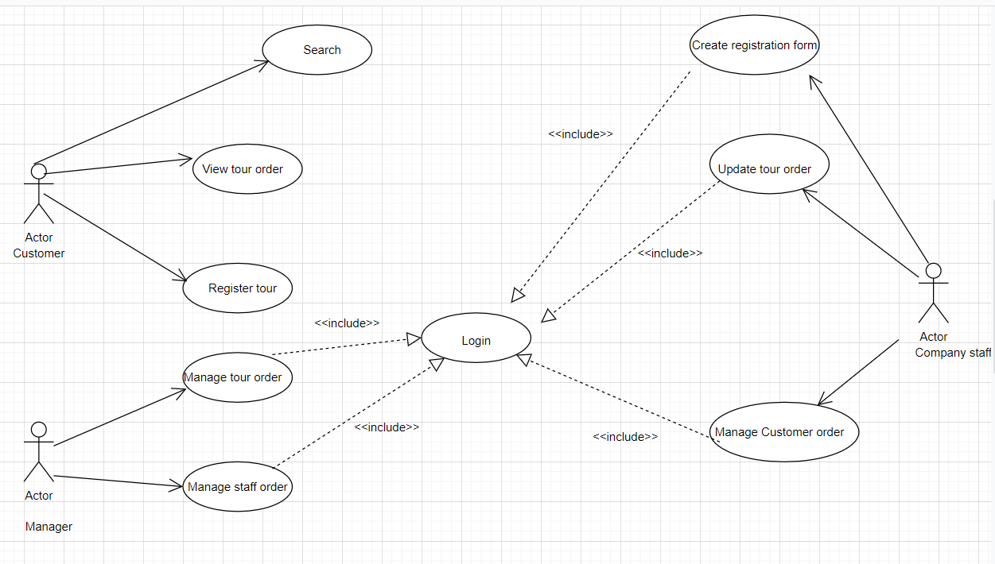

*Hình 1. Main Use-case diagram*

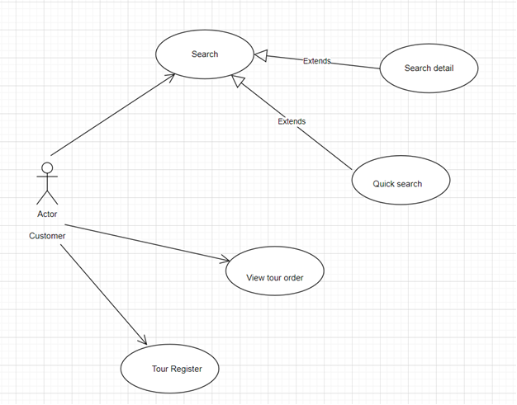

*Hình 2. Customer use-case diagram*

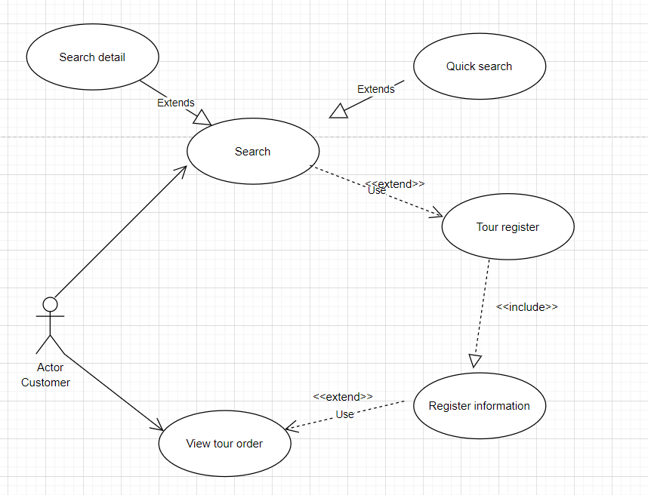

*Hình 3. Tour Booking use-case diagram*

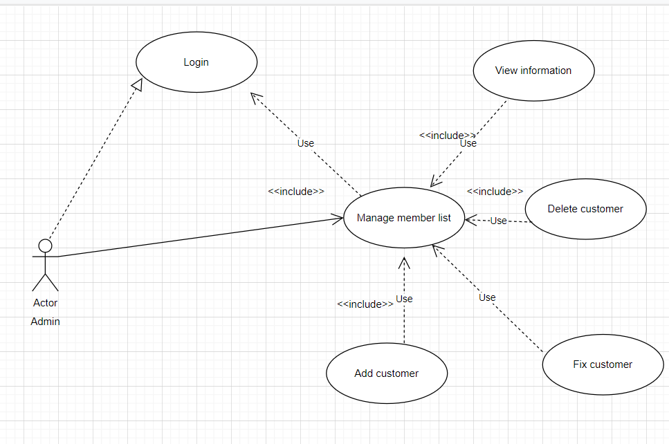

*Hình 4. Customer management use-case diagram*

## Use Case DiagramList of Actors

|  |  |  |  |  |
| --- | --- | --- | --- | --- |
| # | Functions | Admin | Customer | Guess |
| 1 | Login | x | x | x |
| 2 | Log out | x | x | x |
| 3 | Sign Up | x | x |  |
| 4 | Change Password | x | x | x |
| 5 | Manage Accounts of Customers and customers | x |  |  |
| 6 | Look up customer information | x | x |  |
| 7 | Look up Place information | x | x |  |
| 8 | Add/Delete/Edit Places | x | x |  |
| 9 | Add/Delete/Edit Guess | x | x |  |
| 10 | Look up and validate information | x | x |  |
| 11 | . calculation (base, validate, penalty) | x | x |  |
| 12 | Print pay slips | x | x |  |
| 13 | View/Update personal information | x | x | x |
| 14 | Day off | x | x | x |
| 15 | Statistics of customer data (by departsment  Place, gender, major, ...) | x | x |  |
| 16 | Update profile picture | x | x | x |

|  |  |  |
| --- | --- | --- |
| .No | Name of Actor | Short desctiption/Notes |
| 1 | Admin | Admin is the agent who plays the main role of the app system, is the person who operates, manages and monitors all the activities of the system. Admin can perform all functions included in the system of the administrator such as: login, post management, results. tour management, directory management, customer management, search |
| 2 | Customer | Customers access the app, view the contents of the website. Visitors can perform search, view, select, and book tours. See the information about  promotions, tours… |

## List of Use Cases

|  |  |  |
| --- | --- | --- |
| **No.** | **Name of Use Case** | **Short Description/Note** |
| 1 | Login | Check the user's password account information is allowed to access the system. |
| 2 | Register Account | Statistics on the number of delegations in the system. |
| 3 | Log out | Allows users to create tour groups. |
| 4 | Forget Password | Allow user to create, delete, update, and search staffs. |
| 5 | View Personal Information | Allow user to create, delete, update,and search customers. |
| 6 | Manage Tour | Allow user to create, delete, update, and search tours. |
| 7 | Manage Tourist Group | Allow user to delete, update, and search tourist group. |
| 8 | Manage Vehicle | Allow user to create, delete, update, and search areas. |
| 9 | Manage Staff | Allow user to create, delete, update, and search vehicles. |
| 10 | Manage Hotel | Displays personal information of the current user who is logged in and using the system. |
| 11 | Manage Destination | Allow user to create, delete, update, and search destinations. |
| 12 | Manage Area | Allow user to create, delete, update, and search hotels. |
| 13 | Manage Tour Type | Statistical reports on revenue of tour groups. |
| 14 | Manage User | Allow users to log out of their accounts from the system. |
| 15 | Manage Customer | Allow user to delete, update, and search users. |
| 16 | Manage Quantity | Allow user to create, delete, update, and search tour type. |
| 17 | Report Sale | Allows add users to use system. |

## Use Case Specification

**4.1 Login**

|  |  |
| --- | --- |
| **Name** | Login |
| **Target** | For users to log in |
| **User** | Actor admin, Actor customer |
| **Pre-Condition(s)** | Users using devices with software available |
| **Post-Condition** | Log in correctly |
| **Main Flow** | The system records the successful login operation and activity  User access the application  Authentication and access authorization system |
| **Exception Flow** | System login authentication failed public and display the message  User chooses cancel to cancel login |

**4.2 Change account password**

|  |  |
| --- | --- |
| **Name** | Change password account |
| **Target** | Let users change their password account |
| **User** | Admin, Customer , Guess |
| **Trigger** | Enter the correct old password |
| **Pre-Condition(s)** | User login successfully  Users using devices with built-in software |
| **Post-Condition** | New password account updated to database |
| **Main Flow** | The system records successful password account change activity and activity  Users return to the app |
| **Exception Flow** | Password account change authentication fails and displays a message  The user selects cancel to cancel the change |

**4.3 Search Places/ Amenities/ Place_amenities/ locations**

|  |  |
| --- | --- |
| **Name** | Search |
| **Target** | Search Places/ Amenities/ Place_amenities/ locations |
| **User** | Actor admin, Actor customer |
| **Pre-Condition(s)** | Users successfully logged in  Users using devices with software available |
| **Post-Condition** | None |
| **Main Flow** | Search Places/ Amenities/ Place_amenities/ locations |
| **Exception Flow** | None |

**4.4 Comment**

|  |  |
| --- | --- |
| **Name** | Comment |
| **Target** | Comment Places/ Amenities/ Place_amenities/ locations |
| **User** | Actor admin, Actor customer |
| **Pre-Condition(s)** | Users successfully logged in  Users using devices with software available |
| **Post-Condition** | None |
| **Main Flow** | Comment Places/ Amenities/ Place_amenities/ locations |
| **Exception Flow** | None |

**4.5 Book places /acommodation**

|  |  |
| --- | --- |
| **Name** | Book Places |
| **Target** | Book Places |
| **User** | Actor admin, Actor customer |
| **Pre-Condition(s)** | Users successfully logged in  Users using devices with software available |
| **Post-Condition** | None |
| **Main Flow** | Users select the Places package they want to select the view button  See detailed information about the Places  Select the Pay button |
| **Exception Flow** | None |

**4.6 View Places/acommodation**

|  |  |
| --- | --- |
| **Name** | View Places |
| **Target** | View Places |
| **User** | Actor admin, Actor customer |
| **Pre-Condition(s)** | Users successfully logged in  Users using devices with software available |
| **Post-Condition** | None |
| **Main Flow** | Users select the Places package they want to select the view button  See detailed information about the Places |
| **Exception Flow** | None |

**4.7 Manage customer**

|  |  |
| --- | --- |
| **Name** | Manage customer |
| **Target** | Manage customer |
| **User** | Actor admin |
| **Pre-Condition(s)** | Users successfully logged in  Users using devices with software available |
| **Post-Condition** | None |
| **Main Flow** | Manage and view customer information  Manage customer service packages  Manage customer list |
| **Exception Flow** | None |

**4.8 Manage comment**

|  |  |
| --- | --- |
| **Name** | Manage comment |
| **Target** | Manage comment |
| **User** | Actor admin |
| **Pre-Condition(s)** | Users successfully logged in  Users using devices with software available |
| **Post-Condition** | None |
| **Main Flow** | Manage and view customer comment  Manage rate of Places |
| **Exception Flow** | None |

**4.9 Manage Places/amenities/place_amenities/ locations**

|  |  |
| --- | --- |
| **Name** | Manage Places/amenities/place_amenities/ places |
| **Target** | Manage Places/amenities/place_amenities/ places |
| **User** | Actor admin |
| **Pre-Condition(s)** | Users successfully logged in  Users using devices with software available |
| **Post-Condition** | None |
| **Main Flow** | Manage information, time, location, details and prices of services  Add delete edit information |
| **Exception Flow** | None |

## Database Design

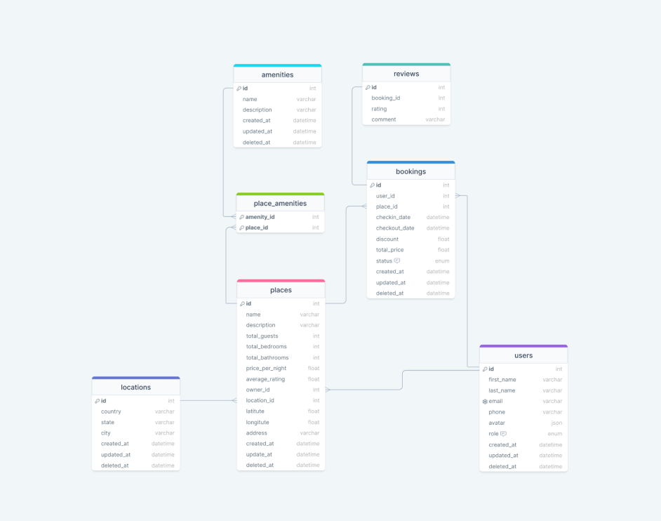

## ERD

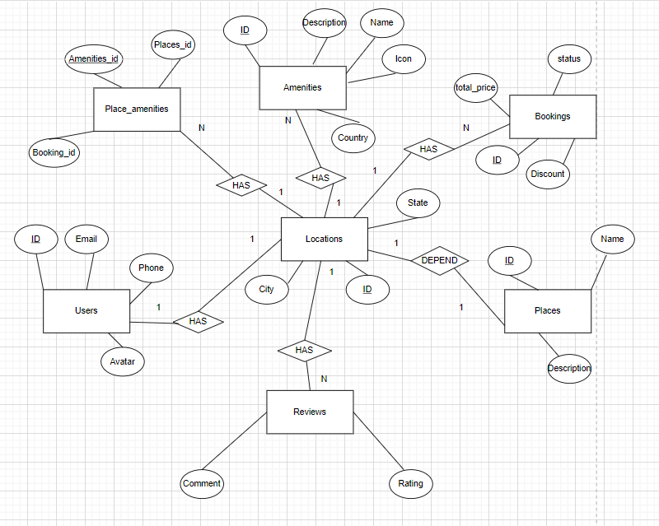

## Activity Diagram

### Information change diagram operation

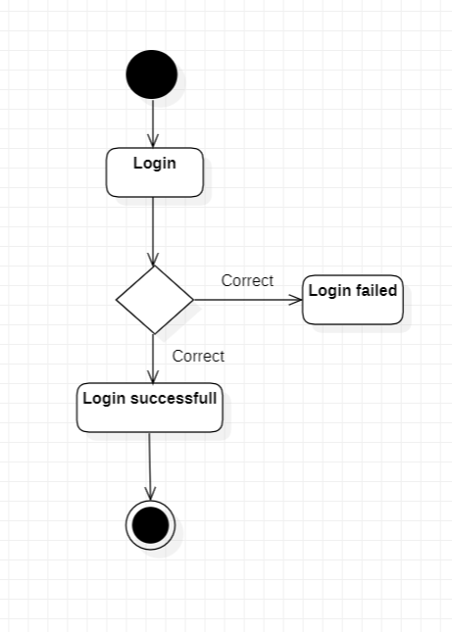

### Information change chart

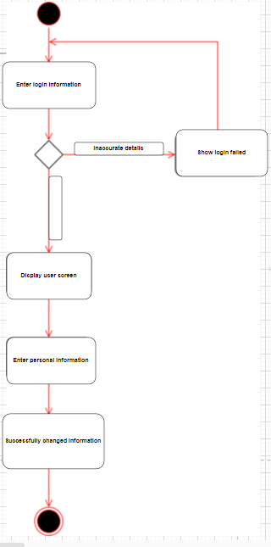

### Diagram of changing password

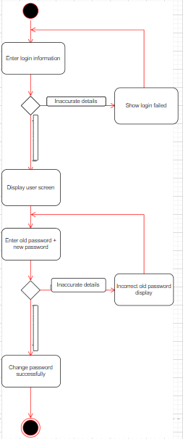

## Class Diagram

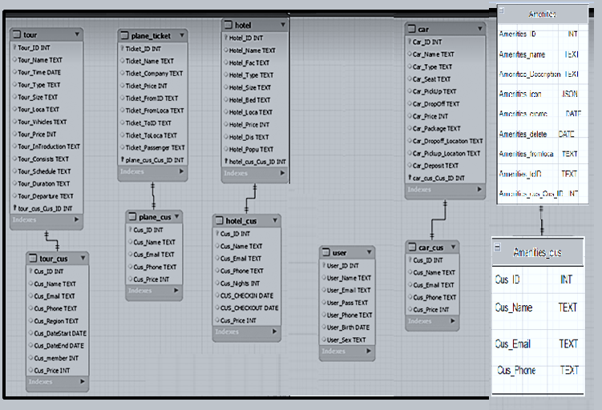

## Sequence Diagram

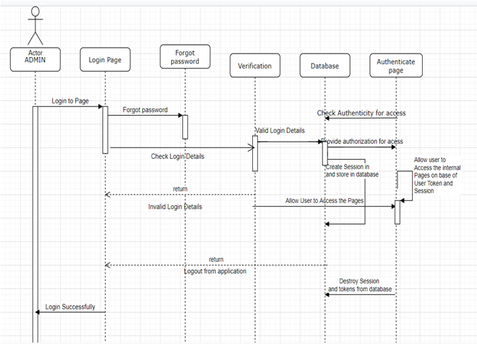 *Hình 8. Main sequence diagram*

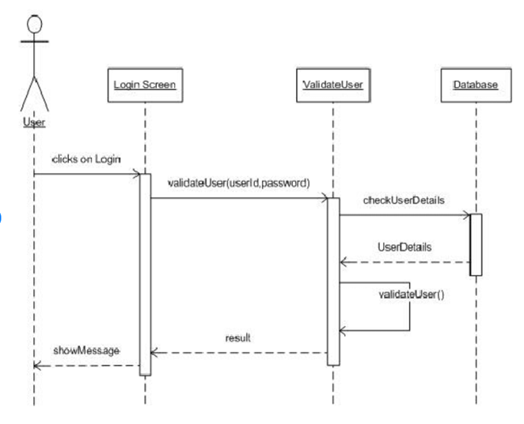

*Hình 9. Login sequence diagram*

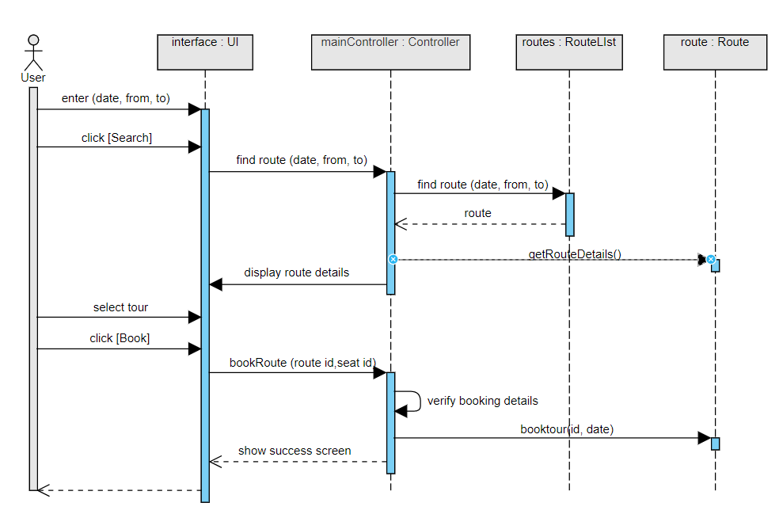

*Hình 10. Tour booking sequence diagram*

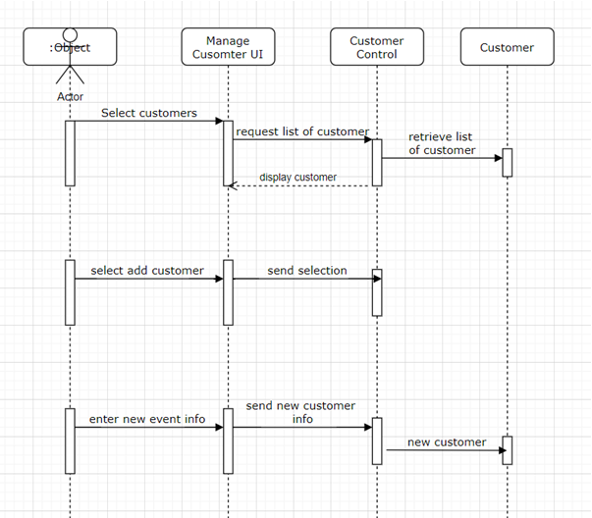

*Hình 11. Customer manage sequence diagram*

# **Non-Functional Requirements**

## Usability

* Efficiency: Customers can easily view a list of customers by different categories. Easy operation, just click on the function on the title bar, the app will display the function you want to perform.
* Cohesion: Suitable for the office space, the company makes it easy for customers to book rooms.
* Easy to learn: Just 10-15 minutes to use the app

## Reliability

SC_1.1: The system should safely use the database

SC_1.2: The system needs to secure the user's information

SC_1.3: The user's password is encrypted for more security

## Ability to support

PC_1.1: App for windows operating system

PC_1.2: Programming language: Go, Html ,Css

PC_1.3: Database: Mysql,Tableplus,Redis

PC_1.4: Code: UI design

## Supportability

To ensure safety support for users, the software will encrypt all kinds of confidential information passwords.

Use the libraries available on the visual studio code, if needed, and can be downloaded for use or maintenance.

## Design Contraints

UI_1.1: Programming language: Go, Html ,Css

UI_1.2: Programming Tools: Visual Studio Code,Goland

UI_1.3: Software process: must log in with a management account to perform editing functions. 4.6.Reusability

The source code of this app can be edited into Tour booking management software

# **Functional requirements**

User Requests

|  |  |  |  |  |  |
| --- | --- | --- | --- | --- | --- |
| System Functions | | Main Use Cases | | Use Case # | |
| User wants to login to the application | | | | | |
|  | | Login | | UC-1.1 | |
| The user wants to log out of the app | | | | | |
|  | | Log out | | UC-1.2 | |
| User wants to register an account | | | | | |
|  | | Sign Up | | UC-1.3 | |
| User wants to change password | | | | | |
|  | | Change account password | | UC-1.4 | |
| Admin wants to manage customer accounts | | | | | |
|  | | Manage Accounts of Customer and Staff | | UC-1.5 | |
| User wants to check customer information | | | | | |
|  | | Look up customer information | | UC-1.6 | |
| Users want to look up Place information | | | | | |
|  | | Look up Place information | | UC-1.7 | |
| User wants to Add/Remove/Edit Place | | | | | |
|  | | Add/Delete/Edit Places | | UC-1.8 | |
| User wants to Add/Remove/Edit Customer | | | | | |
|  | | Add/Delete/Edit Customer | | UC-1.9 | |
| User wants to check . information | | | | | |
|  | | Look up . and validate information | | UC-2.1 | |
| User wants to Add/Remove/Edit . | | | | | |
|  | | . calculation (basic, validate,  punish) | | UC-2.2 | |
| User wants to Print Payslip | | | | | |
|  | | Print pay slips | | UC-2.3 | |
| User wants to View/Update personal information | | | | | |
|  | | View/Update personal information | | UC-2.4 | |
| User Wants Vacation | | | | | |
|  | | On leave | | UC-2.5 | |
| Users want to Statistics customer data (by Place, gender, major, ...) | | | | | |
|  | | Customer data statistics (by Place, gender, specialty)  industry, ...) | | UC-2.6 | |
| User wants to Update profile picture | | | | | |
|  | | Update profile picture | | UC-2.7 | |

# **Interface**

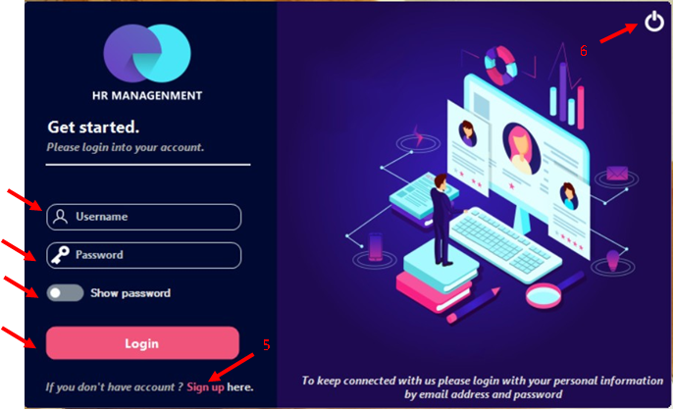

Figure 1: Login UI

|  |  |  |  |
| --- | --- | --- | --- |
| **STT** | **Name** | **Type** | **Function** |
| 1 | textLoginUserName | Text Box | Enter your username |
| 2 | textLoginUserPass | Text Box | Enter your login password |
| 3 | tgShowPass | Toggle Switch | Show password |
| 4 | buttonLogin | Button | Log in to the software |
| 5 | lbSignUpChange | Label | Sign up for an account |
| 6 | guna2PictureBox2 | Picture Box | Exit the software |

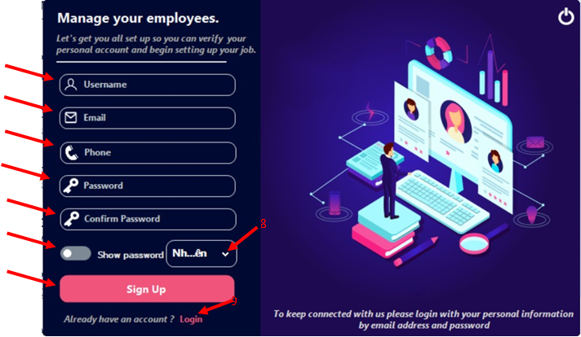

Figure 2: Sign Up UI

|  |  |  |  |
| --- | --- | --- | --- |
| **STT** | **Name** | **Type** | **Function** |
| 1 | textSignUpUserName | Text Box | Enter your registered name |
| 2 | tbEmail | Text Box | Enter customer email |
| 3 | tbPhone | Toggle Switch | Enter the multiplier phone number tablets |
| 4 | textSignUpUserPass | Button | Enter password |
| 5 | textConfirmPass | Label | Re-enter password |
| 6 | tgShowPassSU | Toggle Switch | Toggle Switch Show Password |
| 7 | buttonSignUp | Button | Sign up for an account |
| 8 | cbPermisson | Combo Box | Select Customer Permissions or manage |
| 9 | lbLoginChange | Label | Back to login screen |

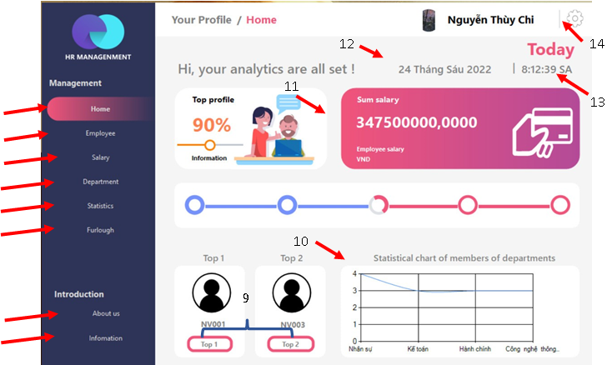

Figure 3: Main Customer UI

|  |  |  |  |
| --- | --- | --- | --- |
| **STT** | **Name** | **Type** | **Function** |
| 1 | btHome | Button | Switch to tab Home |
| 2 | btCustomer | Button | Switch to tab Customer |
| 3 | bt. | Button | Switch to tab . |
| 4 | btPlace | Button | Switch to tab Place |
| 5 | btChart | Button | Switch to tab Statistics |
| 6 | guna2GradientButton1 | Button | Switch to tab Furlough |
| 7 | btAbout | Button | Switch to tab About us |
| 8 | btInfo | Button | Switch to tab Infomation |
| 9 | btView1 và btView2 | Button | Show top 1 và top 2 |
| 10 | chartView | Chart | Show customer graph of  Place |
| 11 | guna2GradientPanel1 | Panel | Show the total . of the  Staff |
| 12 | lbDay | Label | Show current date |
| 13 | lbTime | Label | Show current time |
| 14 | btSetting | Picture Box | Show Setting |

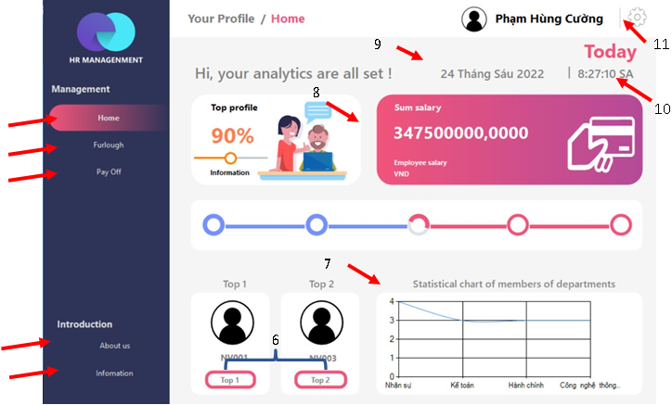

Figure 4: User Main UI

|  |  |  |  |
| --- | --- | --- | --- |
| **STT** | **Name** | **Type** | **Function** |
| 1 | btHome | Button | Switch to tab Home |
| 2 | guna2GradientButton2 | Button | Switch to tab Pay Off |
| 3 | guna2GradientButton1 | Button | Switch to tab Furlough |
| 4 | btAbout | Button | Switch to tab About us |
| 5 | btInfo | Button | Switch to tab Infomation |
| 6 | btView1 và btView2 | Button | Show top 1 và top 2 |
| 7 | chartView | Chart | Show customer graph of  Place |
| 8 | guna2GradientPanel1 | Panel | Display the total . of the  Staff |
| 9 | lbDay | Label | Show current date |
| 10 | lbTime | Label | Show current time |
| 11 | btSetting | Picture Box | Show Setting |

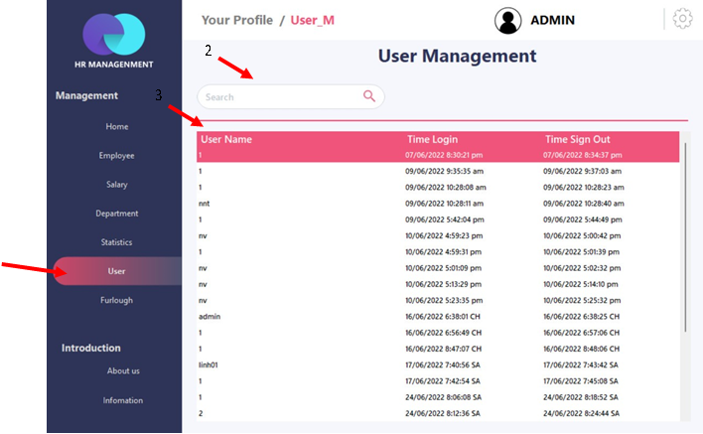

Figure 5: Manage User UI

|  |  |  |  |
| --- | --- | --- | --- |
| **STT** | **Name** | **Type** | **Function** |
| 1 | btUser_Mana | Button | Switch to the User tab |
| 2 | tbTimUser | Text Box | Search account |
| 3 | dataGridViewUser | dataGridView | Display the list of accounts and  time log in, log out |

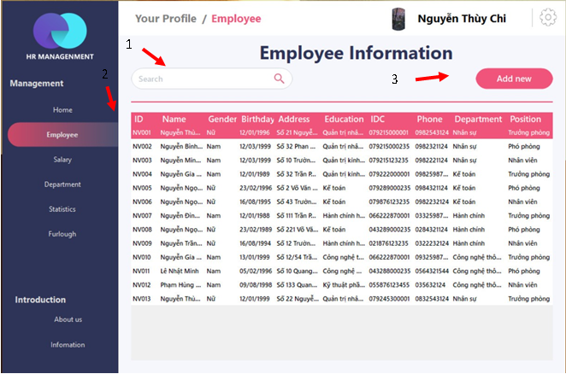

Figure 6: Manage Customer UI

|  |  |  |  |
| --- | --- | --- | --- |
| **STT** | **Name** | **Type** | **Function** |
| 1 | tbTimNHANVIEN | Text Box | Looking for customers |
| 2 | dataGridViewNV | dataGridView | Show list of customers |
| 3 | btAddNew | Button | More staff |

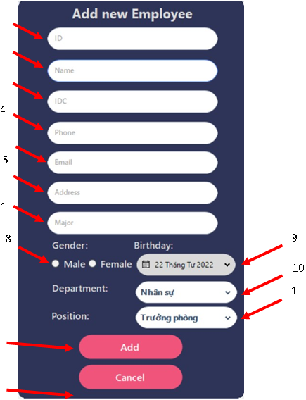

Figure 7: Add customer UI

|  |  |  |  |
| --- | --- | --- | --- |
| **STT** | **Name** | **Type** | **Function** |
| 1 | tbAddID | Button | Enter customer ID |
| 2 | tbAddName | Button | Enter customer name |
| 3 | tbAddIDC | Button | Enter customer CCCD |
| 4 | tbAddPhone | Button | Enter customer phone number |
| 5 | tbAddEmail | Button | Enter Customer Email |
| 6 | tbAddDress | Button | Enter Customer Address |
| 7 | tbAddEducation | Button | Enter Customer Education |
| 8 | radioButton1 và radioButton2 | Radio Button | Select customer's gender |
| 9 | pickerBirthday | DateTime Picker | Enter Customer's Birthday |
| 10 | cbPlace | Check box | Select Staff Place |
| 11 | cbPosition | Check box | Select Customer Position |
| 12 | btAdd | Button | Add Customer |

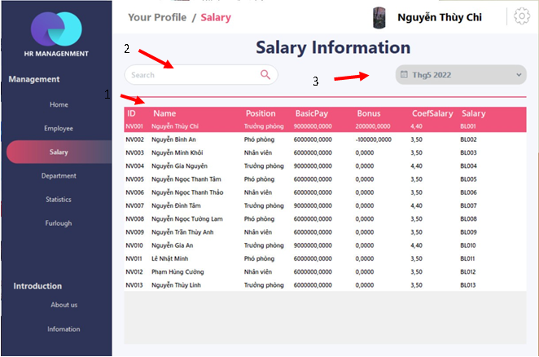

Figure 8: Manage . UI

|  |  |  |  |
| --- | --- | --- | --- |
| **STT** | **Name** | **Type** | **Function** |
| 1 | dataGridViewNV | dataGridView | Show customer list and payroll |
| 2 | tbTimL | Text Box | Looking for customers |
| 3 | picker | Date Time Picker | Select . month to display |



Figure 9: Manage Place UI

|  |  |  |  |
| --- | --- | --- | --- |
| **STT** | **Name** | **Type** | **Function** |
| 1 | picturboxAvatar | Picture Box | Show Customer Avatar |
| 2 | lbTen | Label | Show customer name |
| 3 | lbChucVu | Label | Show customer title |
| 4 | dataGridViewNV | dataGridView | Show list of Places |
| 5 | cbbDP | Combo Box | Select Places to display customers |
| 6 | dataGridView1 | dataGridView | Show customers in the Place |
| 7 | btDeleteDP | Button | Delete Place |
| 8 | tbTimPlace | Text Box | Find staff in the Place |
| 9 | btAdd | Button | Add Place |

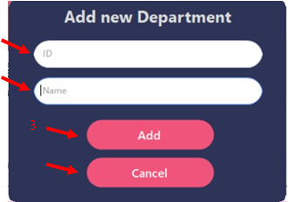

Figure 10: Add Place UI

|  |  |  |  |
| --- | --- | --- | --- |
| **STT** | **Name** | **Type** | **Function** |
| 1 | tbAddID | Text box | Enter the Place ID |
| 2 | tbAddName | Text box | Enter Place Name |
| 3 | btAdd | Button | Add Place |
| 4 | btCancel | Button | Delete Places |

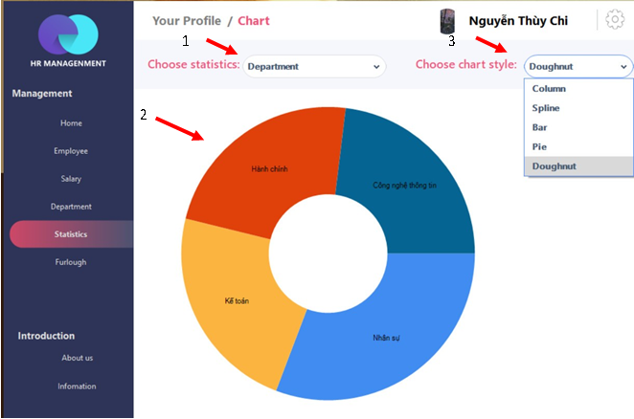

Figure 11: Chart UI

|  |  |  |  |
| --- | --- | --- | --- |
| **STT** | **Name** | **Type** | **Function** |
| 1 | cbbStatic | Combo Box | Select data for statistics |
| 2 | cbbStyle | Combo Box | Choose a Statistical Chart Style |
| 3 | chartView | Chart | Statistical chart display |

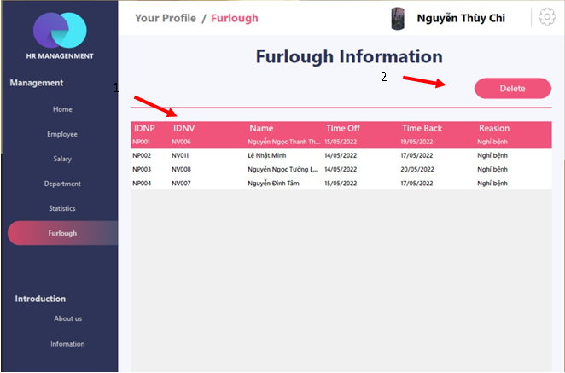

Figure 12: User Manament UI

|  |  |  |  |
| --- | --- | --- | --- |
| **STT** | **Name** | **Type** | **Function** |
| 1 | dataGridViewNP | Data Grid View | Show leave list |
| 2 | btDelete | Button | Delete a leave |



Figure 13: Furlough User UI

|  |  |  |  |
| --- | --- | --- | --- |
| **STT** | **Name** | **Type** | **Function** |
| 1 | dataGridViewTP | Data Grid View | Show list of individual rewards or punishments |
| 2 | dataGridViewNP | Data Grid View | Show individual leave list |
| 3 | btAdd | Button | Add leave |

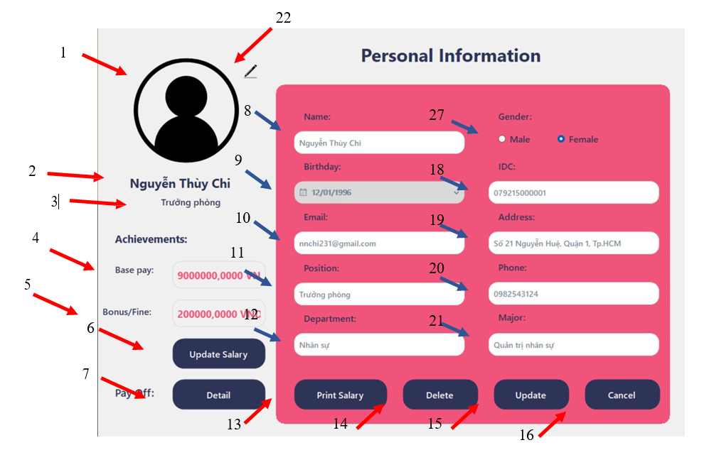

Figure 14: Customer Information UI

|  |  |  |  |
| --- | --- | --- | --- |
| **STT** | **Name** | **Type** | **Function** |
| 1 | picturboxAvatar | Picture Box | Show Customer Avatar |
| 2 | lbTen | Label | Show customer name |
| 3 | lbChucVu | Label | Show customer title |
| 4 | lb. | Label | Show Customer Base . |
| 5 | lbValidate | Label | Show Customer . |
| 6 | btUp. | Button | Update customer . information |
| 7 | btDetail | Button | Show Reward and Penalty details |
| 8 | tbName | Text Box | Show Customer Name |
| 9 | pickerBirthday | Date Time Picker | Show Customer's Birthday |
| 10 | tbEmail | Text Box | Show Customer Email |
| 11 | tbChucvu | Text Box | Show Customer Position |
| 12 | tbPhongBan | Text Box | Show Staff Place |
| 13 | btPrint. | Button | Print customer . information |
| 14 | btDelete | Button | Delete Customer |
| 15 | btUpdate | Button | Update customer information |
| 16 | guna2Button1 | Button | Cancel changes |
| 17 | radioButton1 và  radioButton2 | Radio Button | Show Customer Gender |
| 18 | tbIDC | Text Box | Show Customer Address |
| 19 | tbDiaChi | Text Box | Show Customer Address |
| 20 | tbPhone | Text Box | Show customer phone number |
| 21 | tbChuyenNganh | Text Box | Show Staff Specialization |
| 22 | btChangePicture | Button | Change Customer Avatar |

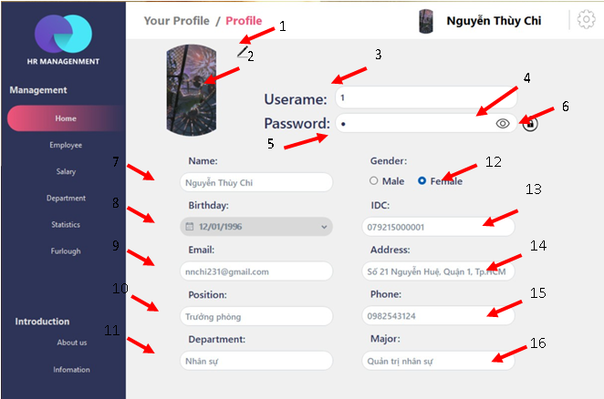

Figure 15: User Profile UI

|  |  |  |  |
| --- | --- | --- | --- |
| **STT** | **Name** | **Type** | **Function** |
| 1 | btChangePicture | Button | Change Customer Avatar |
| 2 | picturboxAvatar | Picture Box | Show Customer Avatar |
| 3 | tbUserName | Text Box | Show Username |
| 4 | btChange | Button | Show Masked Password |
| 5 | tbPass | Text Box | Show Password |
| 6 | btChangePass | Button | Change the password |
| 7 | tbName | Text Box | Show customer name |
| 8 | pickerBirthday | Date Time Picker | Show customer birthday |
| 9 | tbEmail | Text Box | Show customer email |
| 10 | tbChucvu | Text Box | Show customer title |
| 11 | tbPlace | Text Box | Show staff Place |
| 12 | radioButton1 và  radioButton2 | Radio Button | Customer gender display |
| 13 | tbIDC | Text Box | Show CCCD staff |
| 14 | tbDiaChi | Text Box | Show customer address |
| 15 | tbPhone | Text Box | Show customer phone number |
| 16 | tbChuyenNganh | Text Box | Show Customer Education |

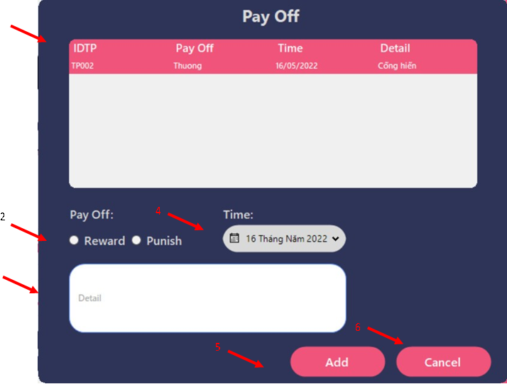

|  |  |  |  |
| --- | --- | --- | --- |
| **STT** | **Name** | **Type** | **Function** |
| 1 | dataGridViewPO | Data Grid View | Show list of rewards and punishments |
| 2 | radioButton1 và  radioButton2 | Radio Button | Choose reward or punishment |
| 3 | tbDetail | Text Box | Enter a Description of Reward or Penalty reason |
| 4 | pickerTime | Picture Box | Choose reward or punishment time |
| 5 | btAdd | Button | Add 1 validate and penalty |
| 6 | btCancel | Button | Cancel extra validate or penalty |

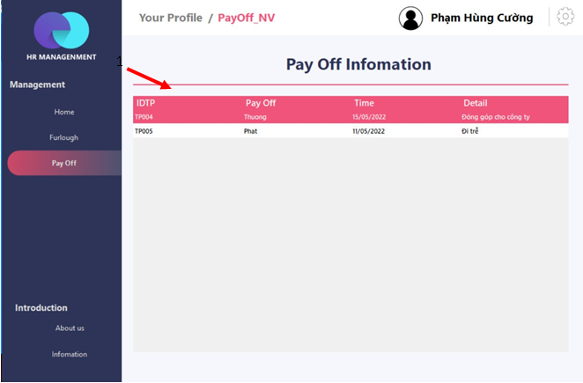

|  |  |  |  |
| --- | --- | --- | --- |
| **STT** | **Name** | **Type** | **Function** |
| 1 | dataGridViewPONV | Data Grid View | Display individual reward and punishment list |

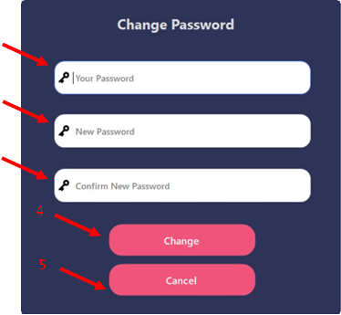

|  |  |  |  |
| --- | --- | --- | --- |
| **STT** | **Name** | **Type** | **Function** |
| 1 | tbPassOld | Text Box | Enter old password |
| 2 | tbNewPass | Text Box | Enter new password |
| 3 | tbConfirmPass | Text Box | Enter a new password |
| 4 | btChange | Button | Change the password |
| 5 | btCancel | Button | Cancel changes |

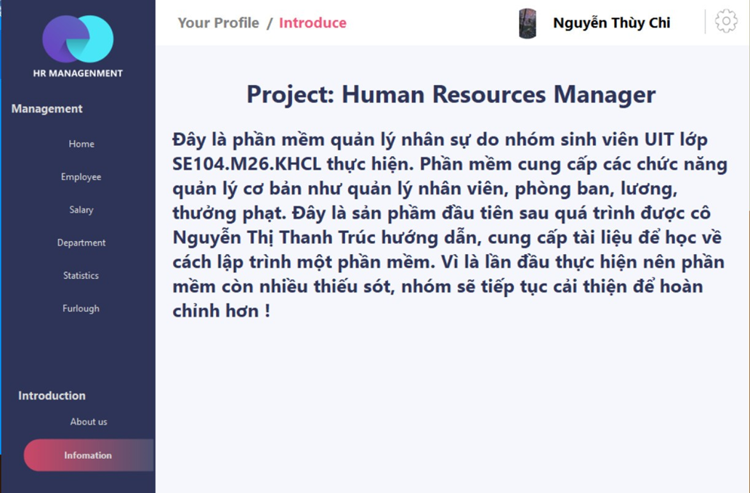

# **Appendixes**

## Glossary

The list below contains all the necessary terms to interpret the document, including acronyms and abbreviations.

|  |  |
| --- | --- |
| **Term** | **Description** |
| BR | Business Rule |
| CBR | Common Business Rule |
| DB | Database |
| MSG | Message |
| UC | Use Case |
| N/A | Not Available or Not Applicable, used to indicate when information in a certain section could not be provided because it does not apply to this application. |
| UI | User Interface |
| SRS | Software Requirements Specification |
| TBD | To be determined or to be defined |
| ID | Identification |

## Messages

|  |  |  |
| --- | --- | --- |
| **Message Code** | **Message Content** | **Button** |
| MSG1 | “Tạo tài khoản thành công” | OK |
| MSG2 | “Tạo tài khoản thất bại, vui lòng thử lại” | OK |
| MSG3 | “Đăng nhập thất bại” | OK |
| MSG4 | “Code sai” | OK |
| MSG5 | “Mật khẩu không trùng nhau” | OK |
| MSG6 | “Lưu thành công” | OK |
| MSG7 | “Lưu thất bại” | OK |
| MSG8 | “Bạn có chắc muốn xóa?” | OK/Cancel |
| MSG9 | “Lỗi” | OK |
| MSG10 | “Thành công” | OK |
| MSG11 | “Đã xóa” | OK |
| MSG12 | “Bạn có chắc muốn thay đổi thông tin này?” | OK/Cancel |
| MSG13 | “Bạn có chắc muốn hủy đơn hàng?” | OK/Cancel |

## Issues List

N/A.